Coupling

- Coupling between two modules is a measure of the degree of interdependence or interaction between the two modules.
- The degree of coupling between two modules depends on their interface complexity. The interface complexity is basically determined by the number of types of parameters that are interchanged while invoking the functions of the module.
- Low cohesion between modules is desired

Classification of coupling
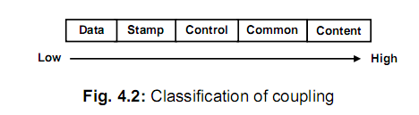

Data coupling
- Two modules are data coupled, if they communicate through a parameter.
- An example is an elementary data item passed as a parameter between two modules, e.g. an integer, a float, a character, etc.
- This data item should be problem related and not used for the control purpose.

Stamp coupling
- Two modules are stamp coupled, if they communicate using a composite data item such as a record in PASCAL or a structure in C.

Control coupling
- Control coupling exists between two modules, if data from one module is used to direct the order of instructions execution in another.
- An example of control coupling is a flag set in one module and tested in another module.

Common coupling
Two modules are common coupled, if they share data through some global data items.

Content coupling
Content coupling exists between two modules, if they share code, e.g. a branch from one module into another module.

